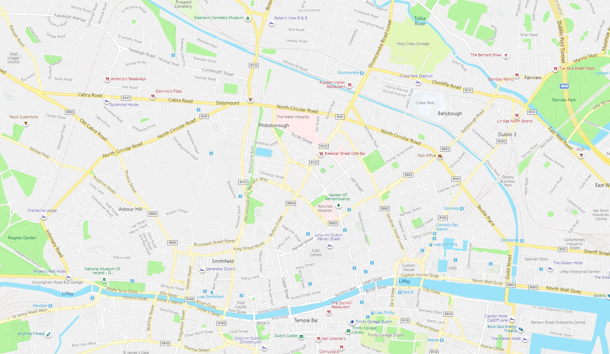
N4 NTA Coach Park
N3
N2
N1
No. Street Name Coordinates Spaces available
N1 Western Way 53°21'18.5"N 6°16'11.9"W or 53.355149, -6.269976 2 Coach Spaces
N2 Liffey Street West 53°20'50.7"N 6°17'07.1"W or 53.347416, -6.285313 3 Coach Spaces
N3 Benburb Street 53°20'51.8"N 6°17'05.3"W or 53.347731, -6.284793 2 Coach Spaces
N4 NTA Coach Park 53°20'57.4"N 6°14'14.7"W or 53.349271, -6.237409 50 Coach Spaces
(The NTA Coach Park is only accessible from Park Lane off North Wall Quay)Total coach parking spaces available = 57 (50 in NTA Coach Park and 7 Dublin City Council on-street parking)

