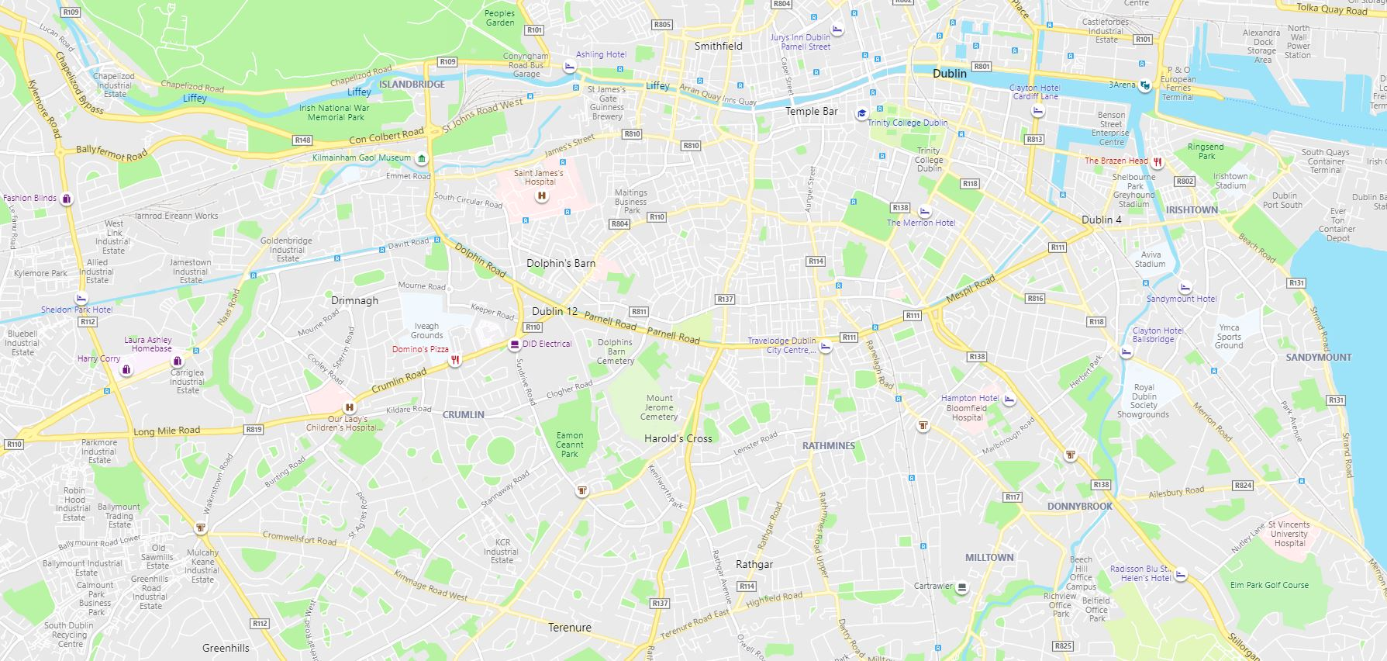
S15
S9
S13
S16
S14
S12
S11
S10
S8
S7
S6
S5
S4
S3
S2
S1

Legend:
No. Street Name Coordinates Spaces available
S1 Victoria Quay 53°20'48.0"N 6°17'14.6"W or 53.346676, -6.287374 19 Coach Spaces
S2 Cook Street 53°20'38.9"N 6°16'29.4"W or 53.344125, -6.274826 8 Coach Spaces
S3 Sandwith Street Lower 53°20'39.1"N 6°14'48.7"W or 53.344198, -6.246852 3 Coach Spaces
S4 Cardiff Lane 53°20'44.3"N 6°14'25.7"W or 53.345629, -6.240471 3 Coach Spaces
S5 Hanover Street East 53°20'41.6"N 6°14'39.9"W or 53.344898, -6.244412 2 Coach Spaces
S6 Erne Street Lower 53°20'40.7"N 6°14'38.2"W or 53.344631, -6.243936 3 Coach Spaces
S7 Inchicore Road 53°20'31.5"N 6°18'33.2"W or 53.342080, -6.309218 1 Coach Space
S8 Grand Canal Place (Guinness Brewery) 53°20'27.7"N 6°17'15.2"W or 53.341035, -6.287550 4 Coach Spaces
S9 Bellevue (Guinness Brewery) 53°20'29.6"N 6°17'05.5"W or 53.341562, -6.284865 3 Coach Spaces
S10 Bull Alley Street 53°20'26.1"N 6°16'16.2"W or 53.340589, -6.271162 6 Coach Spaces
S11 Merrion Square South 53°20'19.5"N 6°14'56.3"W or 53.338742, -6.248957 3 Coach Spaces
S12 Brabazon Place 53°20'18.0"N 6°16'40.0"W or 53.338335, -6.277766 1 Coach Space
S13 Burlington Road 53°19'59.8"N 6°14'49.7"W or 53.333275, -6.247144 1 Coach Space
S14 Herbert Road 53°20'00.8"N 6°13'26.4"W or 53.333549, -6.223995 1 Coach Space
S15 Grand Canal Place @ Echlin Street (Guinness Brewery) 53°20'32.8"N 6°17'17.4"W or 53.342434, -6.288152 1 Coach Space
S16 Newmarket 53°20'16.9"N 6°16'42.7"W or 53.338030, -6.278536 1 Coach Space

Total coach parking spaces available = 60 Dublin City Council on-street parking

